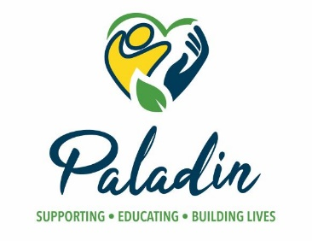
Date
First Last
Address
City, State Zip
Re: 60 Day Termination Notice
Dear First:
Paladin is an organization dedicated to providing the best quality services to all participants. We strive to meet each participant’s needs by delivering services according to an individualized plan. Our goal is to provide supports to each individual in a manner that opens up opportunities to learn, grow and enjoy a meaningful life.

Unfortunately, there are times when Paladin is not best suited to adequately provide for the needs of an individual. After careful review, it has been determined that we have a responsibility to notify you of our intent to terminate the services indicated 60 days from the date of this notice.

Behavior Management Personal Care Assistance (PAC)
Day Habilitation Residential Habilitation
Employment Respite
Group Home (ICF) Transportation

Your Program Manager will follow up with you if there are any additional details or requirements that need to be met.

Best Regards,
Name
Title

Cc: Name of Legal Representative(s), Case Manager

